**AAS 01-159**

**SUN-MARS LIBRATION POINTS AND**

**MARS MISSION SIMULATIONS**

**‡**

**‡**

**‡**

**\***

**Jon D. Strizzi , Joshua M. Kutrieb , Paul E. Damphousse , and John P. Carrico**

The equilibrium points of the Sun-Mars system bring some unique

characteristics to the discussion of future inner solar system exploration

missions, particularly an expedition to Mars itself. Existing research

has identified potential utility and data for Sun-Mars libration point

missions, particularly for satellites orbiting the L and L points serving

1

2

as Earth-Mars communication relays. Regarding these Lissajous orbits,

we address questions of “Why go there?” “How to get there?” and

“How to stay there?” Namely, we address utility and usefulness,

transfer and injection, and stationkeeping. The restricted 3-body

problem involving a spacecraft in that system is reviewed; and past and

present research and proposals involving the use of these orbits are

summarized and discussed. Baseline historical stationkeeping concepts

(ISEE-3, SOHO, ACE) are reviewed and applied to the Sun-Mars

system. We use Satellite Tool Kit (STK)/*Astrogator* for simulation and

analysis of Earth-Mars transfers, Lissajous orbit insertions, and station-

keeping. The resulting data provides confirmation and insight for

existing research and proposals, as well as new information on Mars

transfer and Lissajous orbit insertion strategies to save D V, mission

orbit amplitude dependencies on insertion method, and stationkeeping

sensitivities. These data should prove useful to mission planners and

concept developers for future Mars investigations.

**INTRODUCTION**

*“NASA’s vision is to…focus more of our energy on going to Mars and beyond.”* - Dan

Goldin, AWST, Jan 01

*“All the questions we have about Mars could now be answered…if we could just walk*

*around on the planet for a few days.”* - Michael Malin, Malin Space Science Systems,

National Geographic, Feb 01

As NASA and the space community renew their focus on Mars exploration,

student researchers find several topics awaiting further study. From our work that

originated in an advanced astrodynamics course at the US Naval Postgraduate School, we

became interested in Mars, various aspects of the three-body problem, and the Lagrange

or libration points, and we were eager to team with industry to conduct mission

simulations and analysis. We examined several documented research efforts dealing with

diverse aspects of these topics.6,9,11,14,19,20 A concept that caught our interest was that

introduced by Dr. Pernicka, et al, for a 2-satellite communications relay with one

spacecraft in orbit about each of the co-linear, near Mars, Sun-Mars libration points, L1

and L2.6 Further in-depth work by graduate researchers (Kok-Fai Tai and Danehy)

* Senior Astrodynamics Specialist, Analytical Graphics, Inc., Malvern, Pennsylvania

‡

Department of Aeronautics & Astronautics, US Naval Postgraduate School, Monterey, California

refined this proposal and conducted extensive investigations into the technical and fiscal

aspects of such a mission, including trade studies on communication relay constellation

options.15,16 This analysis resulted in some conclusions and rationale for a Mars

communication relay system that utilizes 2-spacecraft in large amplitude Lissajous orbits,

including system cost and performance measures comparable to a 3-spacecraft

aerosynchronous system. A primary purpose of our study, then, was to re-examine the 2-

vehicle system orbiting the libration points, including transfer orbits and stationkeeping,

through desktop computer simulation using full-force models and the interplanetary

propagation/targeting techniques of the STK/*Astrogator* module. Essentially, we wished

to see how past studies and data compared to our full-force model targeting and

propagation, and to generate new scenarios and data for future missions.

An additional purpose of the project was to demonstrate successful collaboration

between military graduate researchers and industry professionals. Timely, affordable

results from specific research can be obtained when diverse groups such as these can

work, virtually and collaboratively, on pieces of a problem. These ideas flow into

another purpose of the study: to show how commercial desktop computing can be used to

easily create and analyze these types of missions and problems, again leading to faster

and cheaper studies by more researchers.

As output for this study, we expand upon discussions of the usefulness of these

orbits for Mars missions as well as re-examine the 2003 Earth-Mars transfers and L1

libration orbit insertions presented in the original Pernicka study and the follow-on work.

We then expand that simulation and analysis to include the planning horizon of a 2016

transfer and mission orbit insertion, considering an L2 orbit insertion as well. We

investigate the effects of orbit amplitude on insertion D V requirements and show some

innovative mission orbit insertion techniques that may result in D V savings, namely using

a Mars swingby and braking maneuver to assist in the insertion. All of the simulation

and analysis presented here represents a first effort of utilizing full force models and

current desktop tools to generate some data on the Sun-Mars libration point transfer and

communication relay problem. The data does not represent optimized numerical

solutions or proposed mission designs, but rather information and baseline data for

follow-on researchers and mission planners.

**MARS COMMUNICATION CONSTELLATIONS**

Currently, spacecraft missions to Mars rely on their on-board equipment to

provide faint transmissions directly to Earth or to a relay in Martian orbit. The addition

of on-board communication equipment capable of reaching out through the interplanetary

void between Mars and the Earth adds weight, cost, and risk to missions that operate

within tight margins in these areas. To exacerbate this problem, once a lander has made

it safely to the surface, it can only relay information to Earth when it is in direct line of

sight. With a Martian day of just over 24 hours, there exist well over 12 hours of

“blackout” where no signal can be sent to the Earth. With the addition of an orbiting

2

relay, these times are reduced substantially but significant blackouts will still exist. In

order to provide continuous coverage for the entire Martian surface, a minimum of four

satellites (in elliptical orbits) are required6. This, once again, raises the issues of cost and

risk.

Some of these problems can be solved by the use of a communication network

around Mars that takes advantage of the geometry provided by placement at the Sun-

Mars Lagrange points. A minimum of two satellites located at the Sun-Mars L1 and L2

points could provide near continuous coverage for multiple vehicles on the surface and in

orbit6. Lagrange points are equilibrium points in a three-body orbital system, consisting

of two primaries (Sun and Mars) and the much smaller satellite body, whose mass is

sufficiently small that the system can essentially be described with two-body equations.16

The Lagrange points remain at the same location as the two primary bodies rotate about

their center of mass (see Figure 1). The communication satellites would be inserted into

large amplitude orbits about the L1 and L2 points, circling their respective Lagrange

points and the Sun-Mars line. These satellites could communicate with landers anywhere

on the Martian surface, any spacecraft in Martian orbit, and provide the critical

communications link between the Earth and Mars.6

**Figure 1 Geometry of the Lagrange Points of Two Primary Masses P1 and P27**

Other constellations could be used for a Mars communications network, but each

has disadvantages that outweigh the advantages.16 A group (four to six) of low to

medium orbiting relay satellites would ensure that every satellite would cover the entire

planet at some point, but the cost and risk of inserting so many satellites and the limited

instantaneous field of view the satellites can offer do not make it an attractive option.

Four satellites in common-period, inclined orbits, or a Draim constellation, could cover

the entire surface of Mars, but again require twice as many satellites as the Lissajous orbit

concept, as well as the added complexity of a ground station continuously switching from

one satellite to another. An aerosynchronous constellation (Earth geosynchronous

transferred to Mars, approximately 20,462 km altitude) requires three or four satellites,

and works well with ground stations that can simply point to one spot in the sky.

3

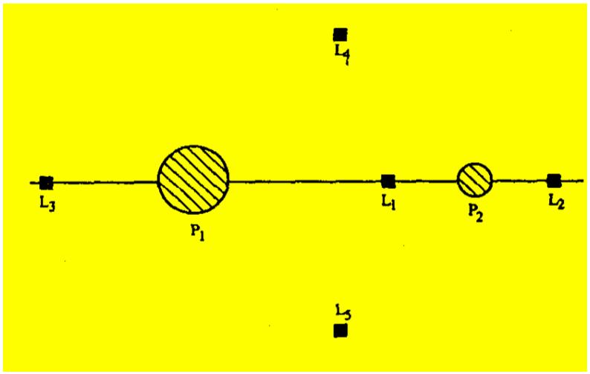

However, in addition to the fact more than two satellites are required, there is virtually no

polar coverage. Another proposal places communication landers on the Martian moons

of Phobos and/or Deimos, but this constellation has the same inefficiencies as the

aerosynchronous satellites with large gaps of polar coverage.

The L1 and L2 orbit constellation requires only two satellites for a fully

operational constellation (each spacecraft sees almost half of Mars at all times), making it

the most attractive option. The Sun is always visible to both satellites, greatly

simplifying power requirements for that spacecraft. Lander pointing requirements are

simple, given the spacecraft is always the same relative distance from the Sun-Mars line,

and the spacecraft stationkeeping budget is relatively small. Disadvantages are

overcoming the approximate one million kilometer distance from the Lagrange points to

the Martian surface. This distance requires a large, high frequency antenna, which could

complicate solar panel design to minimize antenna shadow and may require a more

complex lander communication system to interact with the high frequency signals.

Interference from constant solar radiation along the Sun-Mars line and for certain Earth

viewing geometries may also have to be considered, and the loss of one satellite means

half the planet loses communications coverage for approximately 12 hours.

**SUN-MARS LIBRATION POINT ORBITS**

**Figure 2 Sun-Mars L1 and L2 Halo Orbit Constellation6**

The design of the halo orbit communication network around Mars is a simple but

elegant one, as depicted in Figure 2.6 In order to prevent an unneeded overlap of

coverage, the orbits of each satellite at L1 and L2 would be opposed by 180 degrees but

moving in the same orbital direction. Herein lies a minor problem with this

configuration: because L1 and L2 are at finite distances from Mars (1x106 km), the actual

view of Mars is slightly less than hemispherical. Despite this geometry, the network will

4

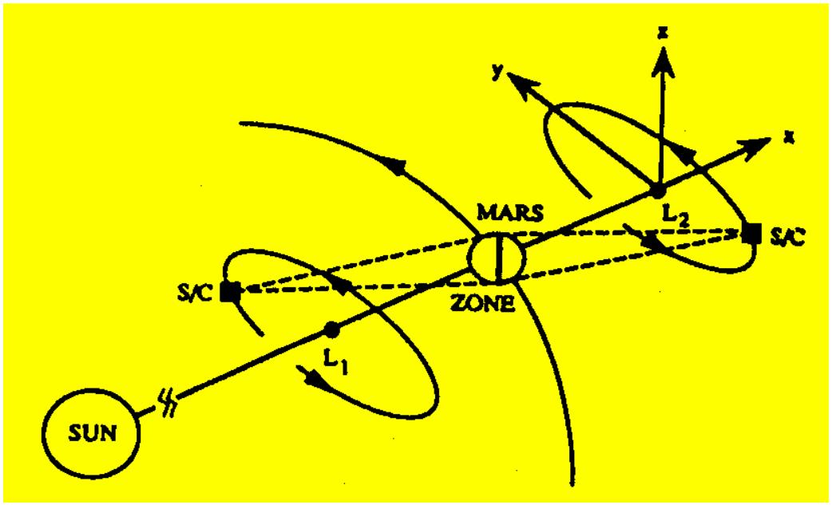

be able to view 99.81% of the planet at all times. The “down time” in this scenario

would be minimal: a vehicle caught in this band would have to wait a mere 1.5 minutes

before coverage would be switched over and reestablished with the other satellite.

In designing the proper orbits in which to place the two satellites, the most

important consideration is that they permit efficient maintenance of the 180 degree

offset.6 An additional consideration is that of avoiding having the satellite cross what is

known as the “solar exclusion zone”, the line between Mars and the Sun. Passing

through this zone, communications would be disrupted due to intense solar interference.

To avoid this problem the orbit must be large enough to avoid this crossing; an orbit of

period greater than 0.9 years should suffice. Another obvious consideration is the choice

of geometry and size of the orbit that reduces the required insertion maneuvers, and thus

cost, from Earth.

As an aside, one might wonder if the L4 and L5 points could play some role in the

design of a communication network around Mars. The L4 and L5 Lagrange points lead

and trail Mars by 60 degrees in its orbit, thus form equilateral triangles with Mars and the

Sun (see Figure 1). The distance from Mars to either of these two Lagrange points is the

same as the distance from Mars to the Sun (227.9 x 106 km). To communicate over these

distances, current interplanetary missions use very large dishes, such as the Goldstone

Deep Space Network (DSN) facility in California, in order to eliminate the need for large,

powerful transceivers on the spacecraft itself. Links over this 230 million kilometer

range would require space borne communications elements whose size, weight, and

power would be on the order of a DSN ground station. The size and power of the needed

equipment for these distances make the L4 and L5 unrealistic as locations for the

network.8

There is one other interesting aspect of the L4 and L5 points worth mentioning

here. While their stability can be exploited for use in missions that require minimal

stationkeeping, this same stability also attracts a multitude of interplanetary bodies that

populate this region of the solar system. These special bodies are known as "Trojans"

because the first few such objects discovered happened to be named for several heroes

from the Trojan War. By convention established by the International Astronomical

Union, all similar objects must be named after Trojan War heroes, Greeks ahead of the

planet and Trojans trailing the planet. Two of the larger Martian Trojans (in the 1-2 km

range), 5261 Eureka and 1998 VF31, represent what could be thousands of other bodies

that reside at the L4 and L5 points making these fairly dangerous places indeed.

Consideration must be made as to whether the benefits of the inherent stability of the L4

and L5 points outweigh the risks of residing there.8

**Mars L1 & L2 Constellation Advantages**

Probably the most significant advantage to using the large amplitude Lissajous

orbit constellation is minimum cost associated with only 2 spacecraft required, when

5

compared to other constellation options.15,16 Additionally, spacecraft orbiting about L1

and L2 can readily see the Sun and Earth, potentially simplifying spacecraft solar cell

placement and communication antenna design.

The vehicles circling the Sun-Mars L1 and L2 points will orbit the Sun-Mars line

with periods on the order of 1 year. The long period dynamics of such orbits may make

them attractive for interplanetary missions with significant communication time delays.

Perhaps even more significantly, on a given day (or series of days) the relay vehicle will

appear motionless and remain in a fixed position relative to the sun (or local midnight

vector, for the L2 relay). Thus, a communication relay tracking system for explorers on

the surface could be simplified and automated for tracking of this position in the sky.

From the surface, there would be only one switch between relay vehicles each day, a

distinct advantage over Draim or low orbiting concepts. The Sun-line geometry may also

allow for simplified and robust safe-modes for the vehicles based on the sun vector.

Since both spacecraft orbit about the Sun-Mars line in large amplitude Lissajous orbits

and avoid eclipsing, the relays would always have access to the sun for their solar cells,

thus allowing reduced battery sizes.

An additional benefit of the unique geometry offered by Lissajous orbit missions

is a secondary mission for these communications relay vehicles as observation platforms.

The L1 satellite is able to perform continuous solar activity monitoring via a secondary

payload on the vehicle, and thus provide advance warning of activity to Mars surface

missions. This could be done using low power, simple instruments for simple early

warning of solar storms/flares, perhaps derived from legacy missions. Regular

monitoring of the sun is thus possible, and can additionally be compared to solar data

from sensors closer to the sun. This secondary mission for solar activity monitoring

increases in importance when the Earth is on the opposite side of the solar system from

Mars. Another observation mission for both spacecraft could include Martian weather

sensing and relay to Mars expeditions and Earth. The L2 vehicle offers the opportunity

of a secondary payload for asteroid and outer solar system observations.

One of the fundamental advantages of Lissajous orbit is, of course, the relatively

small D V maneuvers required for stationkeeping, when compared to other mission orbits.

14

Annual D Vs for each vehicle could to be on the order of 2 m/s

and studies have

produced data showing annual vehicle stationkeeping estimates of 50 m/s for low orbits,

almost 200 m/s for aerosynchronous, and 30 m/s for the inclined common period

missions.15 We provide more discussion of stationkeeping in a later section.

**MARS MISSION SIMULATIONS AND ANALYSIS**

**2003 Direct Insertion into L1 Large Amplitude Lissajous Orbit**

The original study by Pernicka, et al, a system level analysis, used co-planer

transfer trajectories and circular orbits to determine C3 energy and orbit insertion D V

6

requirements for a 2003 Sun-Mars Lissajous communications relay concept. That data

was generated with simplified force models and direct transfer to an orbit about L1. Our

study used STK/*Astrogator* and the targeting process described in detail in the subsequent

section to reproduce a subset of this data for three different times of flight (TOF) for

closer analysis. No Z amplitude specifications were considered for these scenarios. A

screen capture of the trajectory from the STK output is shown in Figure 3, where the

view is of the XY plane looking in the –Z direction, using a Sun-Mars rotating coordinate

frame. We found some agreement between the resulting data, which is presented in the

table that follows.

**Figure 3 L1 Orbit Direct Insertion**

**Table 1 Summary of Direct Transfer to L1 Lissajous; 13 Jun 03 Departure**

**TOF**

**(days)**

**C3 Energy**

**C3 Energy**

**Orbit Insertion**

**D v (km/sec)**

***Original Study***

1.604

**Orbit Insertion**

**D v (km/sec)**

***Full Force Model***

2.807

**2**

**2**

**2**

**2**

**(km /sec )**

**(km /sec )**

***Full Force Model***

8.561 9.553

***Original Study***

170

200

240

7.910

7.986

8.883

14.218

1.196

1.747

2.425

3.400

The differences in C3 energy and D V are most likely due to the differences in the

model parameters of the studies. This study used full force models, non-circular and non-

coplaner transfers, and direct computation of the orbit insertion D V. Based on inspection

of the Mars arrival trajectories, use of actual non-coplaner, eccentric planetary orbits

seems to be a major factor. The data trends are still evident, however: the 200 day TOF

case provides the minimum C3 energy and orbit insertion values (for the cases studied)

and the longer and shorter duration flights require more energy and velocity change.

Thus, for a 2003 mission (a baseline comparison year to be compatible with the original

study) we provide this refined transfer data from our simulations with full-force models

7

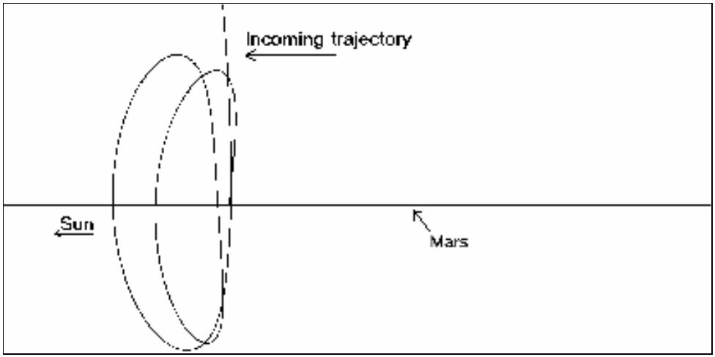

and non-coplaner, eccentric orbits. With these mission scenarios developed, more

extensive simulation and analysis for various transfer parameters could be undertaken.

**2003 Transfer Braking Maneuver at Mars Periapses**

Based on a helpful suggestion by Chauncey Uphoff, we investigated the use of a

braking maneuver at close approach to Mars to lower the D V required for the Lissajous

orbit insertion maneuver. This added a segment to the trajectory design and required

some careful targeting for a close swingby and braking maneuver around Mars (targeting

details discussed in the next section of the paper). We modeled and simulated the 200

day TOF case for the 2003 mission to L1 with the braking maneuver, shown in Figures

4a (looking edge-on at the XZ plane) and 4b (looking down on the XY plane). The data

and a comparison to the direct insertion case are presented in the table below.

**Figures 4a and 4b L1 Orbit Insertion with Braking Maneuver**

**Table 2 Comparison of 2003 Transfers to L1 Orbit; 200 Day TOF**

**Scenario**

**C3 Energy**

**Braking D v**

**(km/sec)**

**Orbit Insertion**

**D v (km/sec)**

2.425

**Total D v**

**(km/sec)**

**2**

**2**

**(km /sec )**

8.883

9.056

Direct Injection

Braking M aneuver

0

2.425

0.960

0.856

0.104

The braking maneuver resulted in a D V savings of 1.465 km/sec, which would

lead to fuel mass savings and/or increase in payload capacity. This type of maneuver

seems promising as a D V conserving technique, and so we adopted it for the other

mission simulations that follow. However, there is plainly room for future investigations

into the applicability of this trajectory for various mission profiles.

**2016 Transfer Braking Maneuver**

In order to provide data from this study that may aid future mission planners or

lead to further research, we modeled a 2016 mission to place two vehicles in orbit about

L1 and L2. We simulated a 200 day TOF as a baseline, as well as a 181 day TOF which,

8

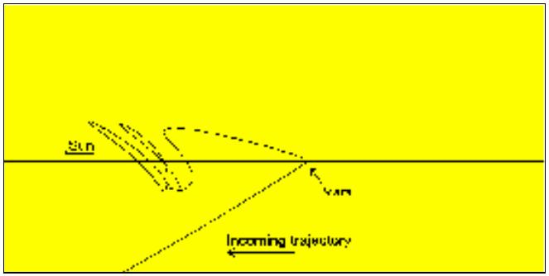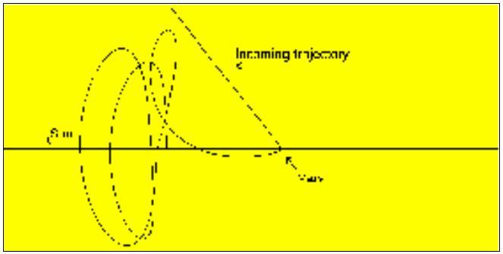

along with the departure date of 20 Feb 2016, was inspired by a JPL Ballistic Earth-Mars

Trajectory study.17 These trajectories are depicted in Figures 5a and 5b and relevant data

is shown in the two tables which follow.

**Figures 5a and 5b L1 and L2 Orbit Insertion with Braking Maneuver**

**Table 3 Comparison of 2016 Transfers to L1 Orbit for Different TOF**

**TOF**

**(days)**

181

**C3 Energy**

**Braking D v**

**(km/sec)**

2.314

**Orbit Insertion**

**D v (km/sec)**

0.047

**Total D v**

**(km/sec)**

**2**

**2**

**(km /sec )**

8.847

10.377

2.360

1.757

200

1.710

0.047

**Table 4 2016 Transfers to L1 & L2 Orbits for 200 Day TOF**

**Orbit**

**C3 Energy**

**Mid-course**

**D v (km/sec)**

**Braking D v Orbit Insertion Total D v**

**2**

**2**

**(km /sec )**

10.377

10.377

**(km/sec)**

1.710

1.708

**D v (km/sec)**

0.047

0.085

**(km/sec)**

1.757

L1

L2

0

0.001

1.795

Table 3 shows that a shorter TOF to Mars can be achieved with a lower C3 energy

value, but that trajectory requires a larger braking maneuver than the longer transfer, to

achieve the same mission orbit. This indicates that with these types of missions the lower

energy transfer may not yield a lower braking and insertion D V specification.

Table 4 shows how two vehicles could start on the same transfer trajectory

initially (as with a simultaneous launch) and the L2 vehicle targeted for it’s close

approach via a small mid-course correction. The simulation method is explained further

in the next section. The *total* TOF to Lissajous orbit insertion is different for each

vehicle, which would assist in the phasing of the vehicles that is required for the

communications relay system to maintain adequate coverage of Mars.

9

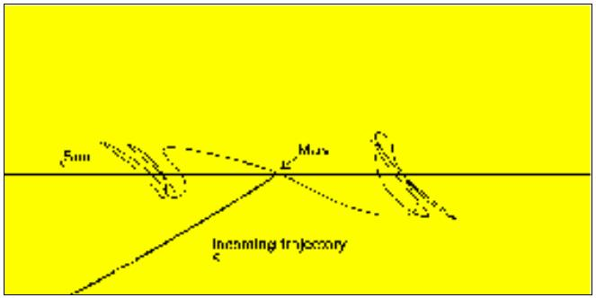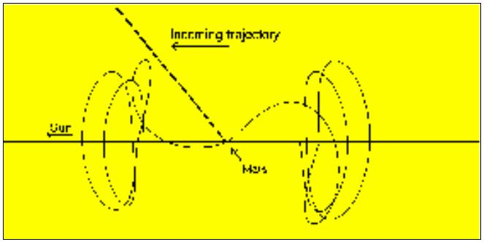

**Z Amplitude and D V Analysis**

Since specific mission performance specifications will drive the Lissajous orbit

shaping requirements, we performed some basic investigations into the relationship

between the orbit Z amplitudes and the D V needed for the braking and mission orbit

insertion maneuvers. We examined the 2016 transfer to an L1 orbit for 200 day TOF,

targeting various amplitude values. The trajectories were very sensitive to small changes

in the maneuvers (see Figure 6, looking towards the Sun), and the results are summarized

2

2

in Table 5 below. The C3 energy for all cases was kept constant at 10.377 km /sec .

**Figure 6 Orbits about L1 with Different Z Amplitudes**

**Table 5 2016 Transfer to L1 Orbit with Varying Z Amplitude**

**Z**

**Periapsis**

**elevation D v (km/sec)**

**(degrees)**

**Mid-course Braking D v**

**Orbit**

**Insertion D v**

**(km/sec)**

0.04181

**Total D v**

**(km/sec)**

**Amplitude**

**(km)**

**(km/sec)**

50000

-4.3

-8.7

-12.3

-14.1

-14.7

-17.6

0.00017

0.00009

0.00003

0

1.71040

1.71034

1.71025

1.71019

1.71017

1.71004

1.75238

100000

140000

160000

167447

200000

0.04283

0.04463

0.04595

0.04653

1.75327

1.75491

1.75614

1.75670

1.75980

0

0.00006

0.04653

The data from Table 5 demonstrate a correlation of the geometry of periapsis with

the Z-amplitude. As a measure of the geometry, the elevation angle of the periapsis

measured with respect to Mars’ orbit plane was used. Very slight changes in the

elevation angle caused dramatic changes in the Z amplitude. (It was also noticed that the

class of the Lissajous orbit could be changed by large variation of elevation angle,

however this was not thoroughly investigated for this study.) As shown in the table, the

mid-course correction D V to change the elevation angle at periapsis is insignificant.

Additionally, there is no significant change in the braking maneuver, leading to the

conclusion that a wide range of Z amplitudes can be achieved with no fuel penalty.

10

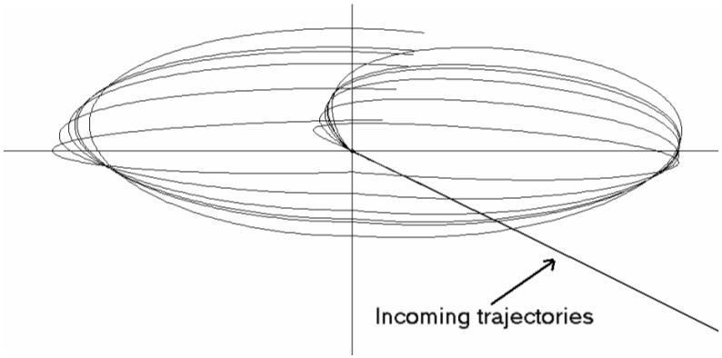

**TARGETING METHODS USING STK/*ASTROGATOR*1**

The transfer from the Earth to a Mars Lagrange orbit was targeted in a series of

steps. The purpose of the targeting was to determine the control variables necessary to

achieve this transfer. The initial orbit state represented the post launch Earth-centered

hyperbolic trajectory. This was specified in target vector form, in the Earth-centered

mean ecliptic and equinox of J2000 coordinate system. The seven parameters of the

target vector are: epoch, radius of periapsis, C3 energy, right ascension (RA) and

declination (Dec) of the outgoing hyperbolic asymptote, the velocity azimuth at periapsis,

and the true anomaly. (Note: C3 is defined as negative the gravitational parameter of the

central body divided by the semimajor axis. For hyperbolic orbits this is the square of the

hyperbolic excess velocity.)

For this study, the epoch was chosen to match previous work, the true anomaly

was set to zero, the velocity azimuth set to 90 degrees, and the radius of periapsis set to

6678.0 km. This represents a satellite near the Earth at perigee. The remaining

parameters, C3 energy and the direction of the trajectory (RA and Dec of the asymptote)

were used as control parameters. Two methods of insertion into Lagrange orbits were

utilized and are discussed separately below.

**Direct transfer to L1 Lagrange orbit**

For the direct transfer from Earth to the L1 Lagrange orbit, the control parameters were adjusted using a

differential corrector technique to achieve three constraints at the point the trajectory crossed the ZX plane

of Sun-Mars rotating libration-point coordinate system (this is the plane containing the Sun-Mars line and

perpendicular to Mar's orbit plane). The three constraints are the desired epoch of arrival, and the X and Z

positions in the Sun-Mars rotating libration-point coordinates.

Once the desired time and position was achieved, the three components of the

Lagrange-orbit insertion maneuver (LOI) was targeted as an impulsive D V maneuver in

four steps. First, LOI was targeted to achieve somewhat ideal velocity components for

the Lissajous orbit at this point. Velocity in the X and Z rotating libration point

directions were targeted to zero. Velocity in the Y direction was targeted to -0.16 km/sec

(a representative value from previous analysis). Second, the LOI maneuver was

corrected so that after propagating the trajectory a half revolution to the first ZX plane

crossing, the X component of velocity (Vx) would be zero (this represents a

perpendicular plane crossing when projected into the XY plane, and is the same energy

balancing technique mentioned by Dunham and Roberts 14). After achieving the first ZX

plane crossing, the third and fourth steps were to correct the LOI maneuver to achieve Vx

of zero at the second, and then the third ZX plane crossings.

11

**Transfer using braking maneuver at Mars periapsis**

The transfer to a Mars Lagrange point orbit using a braking maneuver at the close

approach at Mars before the LOI maneuver was also targeted in stages. First, the target

vector control parameters were adjusted by the differential corrector to achieve an epoch

at periapsis Mars, and B-Plane components to place the trajectory on the anti-Sun side of

Mars. Since this stage is just a first guess, the values used were B-dot-T of -10,000 km,

and B-dot-R of 0.0 km.

The second step refined this to the desired close approach conditions. Using the

same control parameters, the radius of close approach was used instead of B-dot-T, and

was targeted to a radius of 3,600 km (about 200 kilometers altitude).

After the constraints at periapsis were met, the magnitude of a retrograde braking

maneuver (anti-velocity direction) was used at periapsis to shape the trajectory until the

trajectory crossed the XZ plane at the desired X distance in the Sun-Mars rotating

libration-point coordinate system (XRLP). After the retrograde maneuver was calculated,

the LOI maneuver was planned using the same 4-step method previously described for

the direct transfer.

The transfer to the L2 Lagrange orbit was planned in a similar manner, except that

the trajectory must pass on the Sunward side of Mars at the close approach. This was

done using a mid-course correction (MCC) maneuver as a control parameter, which also

allowed the initial transfer parameters to be the same for both the L1 and L2 vehicles.

**Transfer Using Braking Maneuver to Achieve Desired Z Amplitude**

The concept for targeting a desired Z amplitude for the Lagrange orbit is

analogous to the technique using Earth's moon as described by Sharer, et al.21 The Z

amplitude can be directly controlled as a function of the position of the trajectory as it

passes through its close approach to Mars.

The initial targeting is the same B-Plane targeting described above: first B-dot-T

and B-dot-R, and then B-dot-R and Radius of periapsis. The initial target vector

parameters were not used at this step because the corrections to the parameters were too

small, being on the order of a double precision number. Instead, a MCC maneuver was

used 30 days after Earth departure.

After the epoch, B-plane, and radius of periapsis constraints were achieved, the

retrograde braking maneuver was targeted to achieve the as described above. Then the Z

distance (amplitude) was checked, and if it was significantly far from the desired value,

12

the previous step was repeated with a different B-dot-R value. (B-dot-R is directly

related to the elevation of periapsis with respect to the Mars’ orbit plane.)

The next stage involved targeting the four constraints that must be simultaneously

met: the epoch at periapsis, the radius of periapsis (to prevent the trajectory from hitting

Mars), the X position at LOI, and the Z amplitude. In addition to the three components of

the MCC maneuver, the magnitude of the braking maneuver was also used as a control.

Once this step converged, the LOI maneuver was targeted using the same 4-step

method described above for the direct insertion.

**STATIONKEEPING**

Due to the precarious nature of the Lissajous orbit, precise and continuous

stationkeeping (SK) techniques must be employed. Additionally, the precision required

for certain missions located around the Sun-Mars Lagrange points requires the fidelity of

such SK maneuvers to be extremely high. SK D Vs as little as 1 mm/sec could be

required.

Stationkeeping techniques fall into two major categories.14 The first, referred to

as a “tight” control technique, attempts to target the vehicle back to a nominal three-

dimensional path. The second is the “loose” control technique that uses a simpler

“orbital energy balancing” strategy to closely mirror a Lissajous orbit. The two control

techniques differ only in the number of D V components that are varied. The loose

technique will simply vary one component of D V while the tight technique varies two or

more to achieve a nominal Lissajous orbit.

**History14,18**

The third International Sun-Earth Explorer (ISEE-3) flown to the Sun-Earth L1

point in 1978 used the tight control technique in an attempt to maintain its trajectory as

close to a nominal halo orbit as possible. This mission, being the first to orbit a Sun-

Earth libration point, had the luxury of a large supply of fuel to allow for uncertainties in

the insertion to and maintenance of the new orbit. The relatively small errors

encountered during insertion into the halo orbit left a large amount of fuel that could be

used specifically for stationkeeping. Over the four years that ISEE-3 was established at

the L1 point, 15 SK maneuvers were performed totaling 30.06 m/sec at an average of

2.00 m/sec per maneuver. The time between the maneuvers averaged 82 days.

While the large amount of fuel planned for the ISEE-3 mission allowed for very

tight control of its halo orbit, a more optimal SK method was planned for the Solar

Heliospheric Observatory (SOHO). Prior to its establishment at the Sun-Earth L1 point

in 1996, SOHO mission planners sought ways in which to decrease its SK costs. If the

13

complexity of SK maneuvers for SOHO could be dramatically reduced, or “loosely”

controlled, the fuel load, and therefore costs, could be also be reduced. In the “orbital

energy balancing” technique that evolved, only one component of D V, in this case the x-

component, would be varied. The result of this simplification achieved a threefold

reduction in SK costs from roughly 7.5 m/sec per year for ISEE-3 to less than 2.3 m/sec

per year for SOHO.

The major drawback with the loosely controlled technique used on SOHO was

that it did not maintain a periodic halo orbit *precisely*. The resultant orbit was, however,

a Lissajous path that mirrored the nominal halo orbit so closely that for all practical

purposes it could be considered equivalent. The loose control technique was therefore

proven as an effective means of achieving lower SK costs when precise orbit mapping

was not necessary.

**Stationkeeping for the Sun-Mars Lissajous Orbits**

For future missions to Mars using the Sun-Mars Lagrange points, mission

planners will have to consider several factors prior to making a decision on the SK

technique to be used. Obviously mission requirements will dictate whether the loose

control technique can be used to optimize SK costs or if the higher precision of the tight

technique is necessary. In our example of a communication system in orbits about the L1

and L2 points, the loose technique should be sufficient as a communication system’s

global nature does not depend on a precise halo orbit. Furthermore, the success of ACE

and SOHO with using the loose technique has served to prove its utility and make it a

preferred approach for scheduled missions to Sun-Earth Lagrange points.

The frequency of such SK maneuvers depends mainly on two factors. The first,

and most crucial, is the accuracy of the insertion maneuver. If this maneuver is

performed with a minimal D V error, the SK that follows is also minimized. If, however,

the insertion D V error is greater than that expected the magnitude of the SK maneuvers

will increase and the SK costs will rise.

The second factor in SK frequency determination is the effect that subsequent SK

burns have on the overall orbit error. This can be further broken down to the actual

magnitude of the orbit error at the end of the last burn, the time since that burn, and the

accuracy of the burn itself as executed. Obviously, this orbit error will increase with time

and the larger the error, the sooner a subsequent burn will need to be performed. The key

here is to minimize the magnitudes of the burns.14

Once the frequency and magnitude of the required SK maneuvers are determined,

the optimal timing of such maneuvers will need to be considered. For the

communications system example, the timing of SK burns is critical so as to prevent

unexpected and inconvenient losses in communications coverage to the users on the

Martian surface. One solution to such a problem is to overlap the SK maneuvers with the

14

spacecraft’s preplanned attitude and momentum adjustments. This allows the attitude

control, momentum management, and SK maneuvers to complement one another and

minimizes the down time of the system.

Dunham and Roberts have shown that small D V errors on order of 0.1 mm/sec for

the Sun-Earth/Moon system cause noticeable deviation from the nominal after about 3

revolutions in the Lissajous orbit. The same error was applied to the Sun-Mars L1

Lissajous orbit as shown in Figure 7. This error caused noticeable deviations after only 1

and a half revolutions. However, because the period of the Mars Lissajous is about twice

that of the Earth Lissajous, the deviations occur approximately after the same duration.

This is an indicator that the stationkeeping requirements for the Mars Lissajous will be on

the same order as seen for the Earth missions, in terms of fuel used per year. Of course, a

thorough error analysis study could be made later to prove this, accounting for the errors

and uncertainties.

**Figure 7 – Effect of small errors on Lissajous orbit**

**CONCLUSION**

The trends from the previous studies are still valid when using full force models,

however the actual magnitudes of the maneuvers can be significantly increased. This

current work also highlights the fact that the minimum departure C3 energy does not

always correspond to the minimum LOI maneuver. Additionally, the use of a braking

maneuver at a low altitude (200 km) Mars periapsis prior to LOI saves significant

spacecraft on-board fuel. The geometry of this close approach can be taken advantage of

to control the Z amplitude and class of the Lissajous orbit.

The loose control technique for stationkeeping would be appropriate for the L1

and L2 communication relay concept. The stability of these orbits are on the same order

as the Sun-Earth orbits in terms of deviations from nominal as a function of time. One

must remember, however, that because the period of these Sun-Mars Lissajous orbits are

twice as long as Sun-Earth orbits, errors cause deviations more quickly with respect to

15

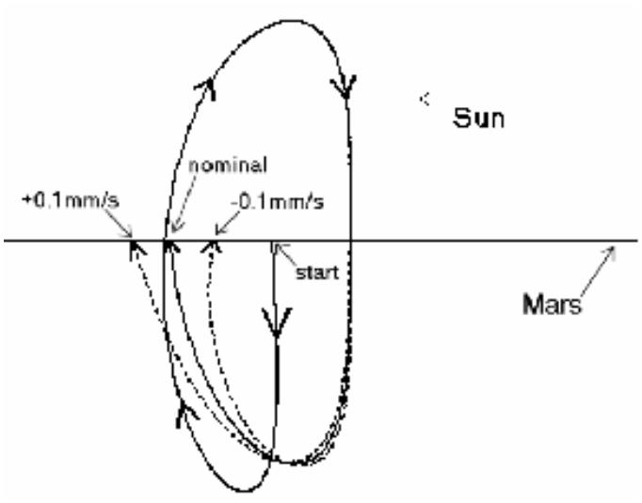

position in the orbit. Therefore, it is anticipated that annual stationkeeping costs should

be similar to Sun-Earth orbits.

**ACKNOWLEDGMENTS**

The authors wish to thank Hank Pernicka and Chauncey Uphoff for their

invaluable assistance with portions of this study, and Dean Rudy Panholzer at the US

Naval Postgraduate School for his support of the conference presentation effort.

**REFERENCES:**

1. J. Carrico et al., "Rapid Design of Gravity Assist Trajectories," Proceedings of the

ESA Symposium on Spacecraft Flight Dynamics held in Darmstadt, Germany, 30

September - 4 October 1991 (ESA SP-326, December 1991).

2. C.D. Brown, “Spacecraft Mission Design,” AIAA Education Series, 1992, pp. 96-98.

Brown.

3. V.G. Szebehely, “Adventures in Celestial Mechanics,” University of Texas Press,

Austin Texas 1989.

4. D.A. Vallado, “Fundamentals of Astrodynamics and Applications,” McGraw-Hill,

New York, 1997.

5. D. Halliday, R. Resnick, J. Walker, “Fundamentals of Physics, Extended,” John Wiley

& Sons, New York, 1997.

6. H. Pernicka, D. Henry, M Chan, “Use of Halo Orbits to Provide a Communication

Link Between Earth and Mars,” AIAA Paper 92-4584, 1992.

7. V.G. Szebehely, “Theory of Orbits: The Restricted Problem of Three Bodies,”

Academic Press, New York and London, 1967.

8. Website: www.users.skynet.be, “The Guide to the Universe.”

9. K.C. Howell, “Families of Orbits in the Vicinity of the Colinear Libration Points,”

AIAA Astrodynamics Specialist Conference, Paper 98-4465, August 1998.

10. Website: www.map.gsfc.nasa.gov, “Microwave Anisotropy Probe.”

11. G. Gomez, K.C. Howell, J. Masdemont, C. Simo, “Station-Keeping Strategies for

Translunar Libration Point Orbits,” AIAA Spaceflight Mechanics Meeting, Paper 98-168,

1998.

16



12. P. Keaton, “A Moon Base/Mars Base Transportation Depot,” Los Alamos National

Laboratory, LA-10552-MS, UC-34B, September 1985.

13. E. Belbruno and J. Carrico, "Calculation of Weak Stability Boundary Ballistic Lunar

Transfer Trajectories," AIAA/AAS Astrodynamics Specialist Conference, AIAA Paper

2000-4142, 14-17 August 2000.

14. D. Dunham and C. Roberts, "Stationkeeping Techniques For Libration-Point

Satellites," AIAA/AAS Astrodynamics Specialist Conference, AIAA Paper 98-4466, 10-

12 August 1998.

15. W. Kok-Fai Tai, “Mars Communication Network Design Trade Study,” Master of

Science Thesis, San Jose State University, 1998

16. M. Danehy, “Martian Communications Network Design Trade Study,” Master of

Science Thesis, San Jose State University, December, 1997.

17. S. Matousec and A. Sergeyevsky, “Feasible Ballistic Earth to Mars Trajectories from

2002 to 2020,” chart for Mars Surveyor Program Advanced Missions Studies Office,

March, 1998.

18. R. Farquhar, “The Flight of ISEE-3/ICE: Origins, Mission History, and a Legacy,”

AIAA Paper 98-4464, August 1998.

19. R. Farquhar, “Stationkeeping in the Vicinity of Collinear Libration Points with an

Application to a Lunar Communications Problem,” AAS Science and Technology Series:

Space Flight Mechanics Specialist Symposium, Vol. 11, pp. 519-535 (Presented in

Denver, CO, July 1966).

20. R. Farquhar, et al, “Trajectories and Orbital Maneuvers for the First Libration-Point

Satellite,” Journal of Guidance and Control, Vol. 3, No. 6, Nov-Dec, 1980, pp. 549-554.

21. P. Sharer, J. Zsoldos, and D. Folta, “Control of Libration Point Orbits Using Lunar

Gravity-Assisted Transfer,” AAS-93-295, Spaceflight Dynamics 1993, Vol. 84, Part 1:

Advances in the Astronautical Sciences, Proceedings of AAS/NASA symposium, April,

1993.

17